Test Case: tc002_SPX_Dev5_Crear_Requisicion_Spot_Tipo_Cobro_Project
Step 1 - Enter username and password and click to button Enter: Credentials Entered
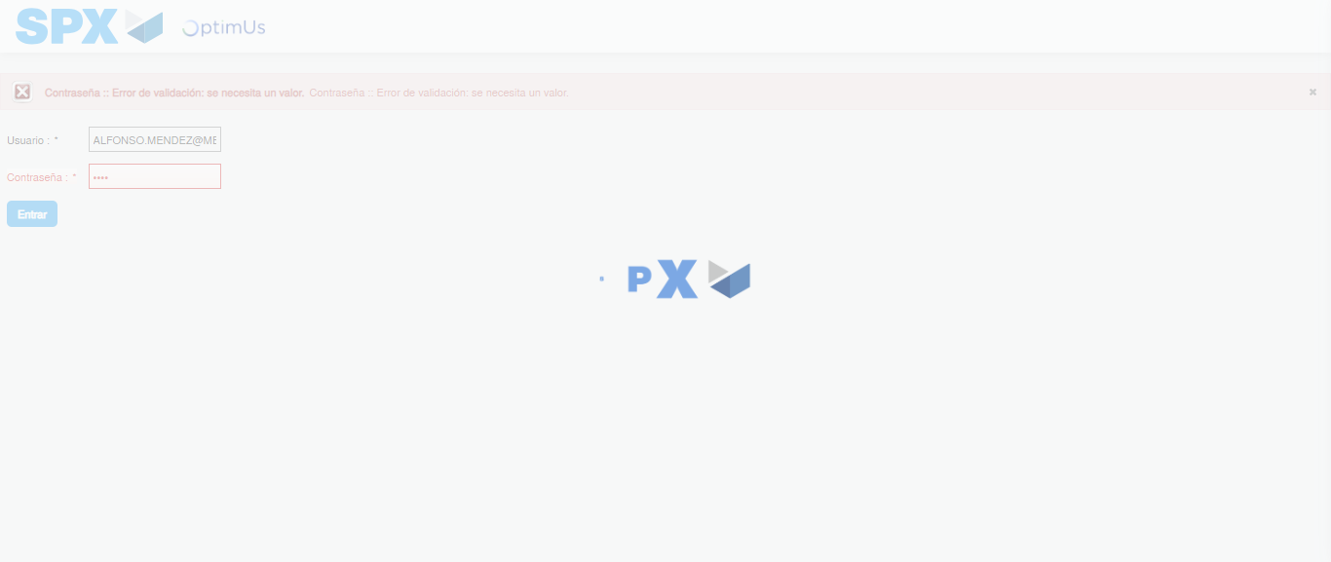Image file-name: QC_Testing-tc002_SPX_Dev5_Crear_Requisicion_Spot_Tipo_Cobro_Project-1783374272513

Step 2 - Select to UEN and Access to Spot Buy Requisitions : UEN Correctly selected and Correct access
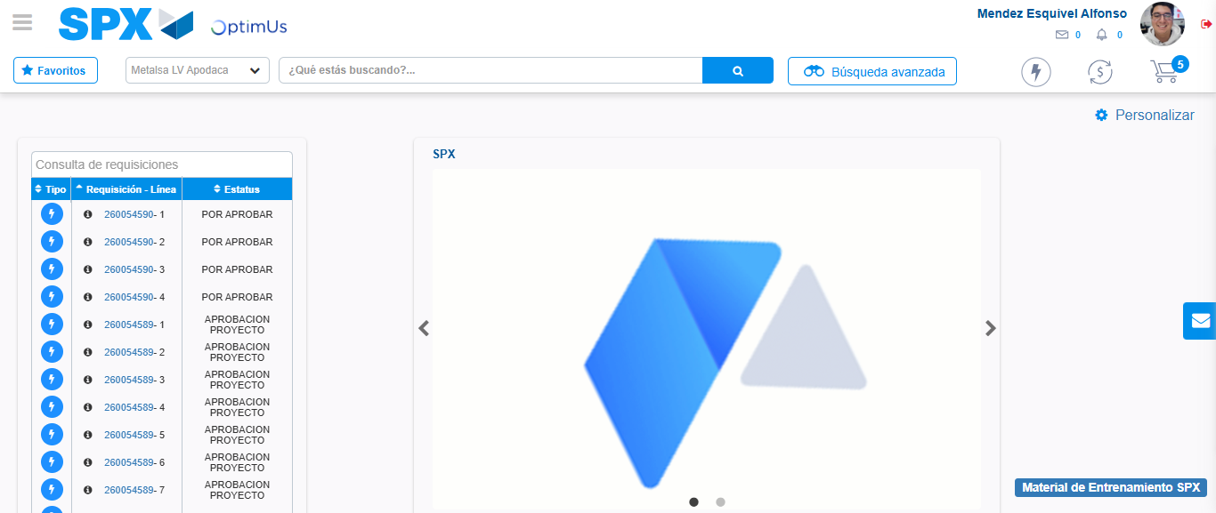Image file-name: QC_Testing-tc002_SPX_Dev5_Crear_Requisicion_Spot_Tipo_Cobro_Project-1783374356890

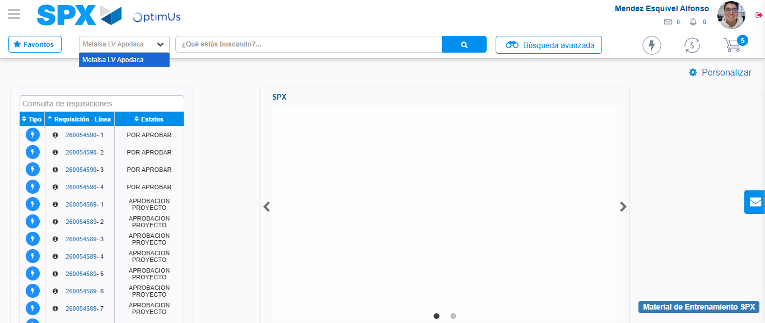Image file-name: QC_Testing-tc002_SPX_Dev5_Crear_Requisicion_Spot_Tipo_Cobro_Project-1783374359404

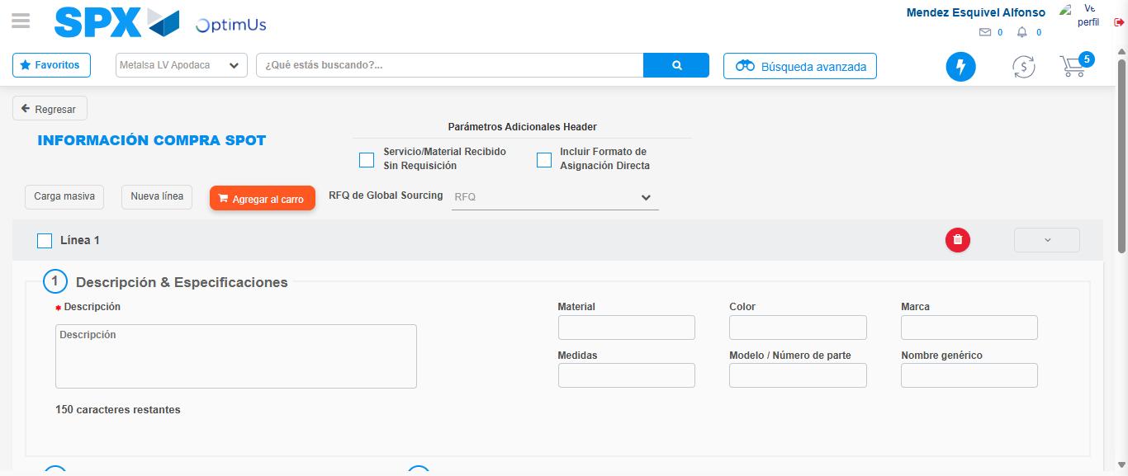Image file-name: QC_Testing-tc002_SPX_Dev5_Crear_Requisicion_Spot_Tipo_Cobro_Project-1783374365710

Step 3 - Data Capture Spot Buy Requisition: Data captured correctly
Image file-name: QC_Testing-tc002_SPX_Dev5_Crear_Requisicion_Spot_Tipo_Cobro_Project-1783374365938

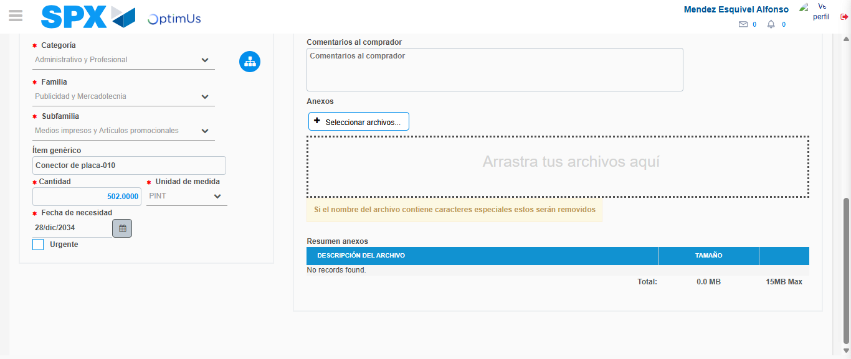Image file-name: QC_Testing-tc002_SPX_Dev5_Crear_Requisicion_Spot_Tipo_Cobro_Project-1783374376085

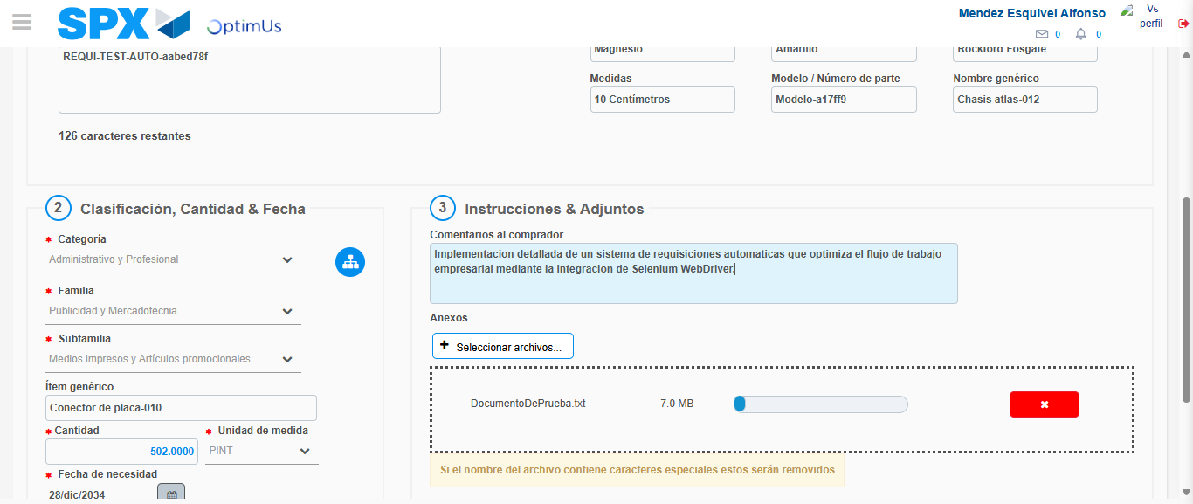Image file-name: QC_Testing-tc002_SPX_Dev5_Crear_Requisicion_Spot_Tipo_Cobro_Project-1783374376831

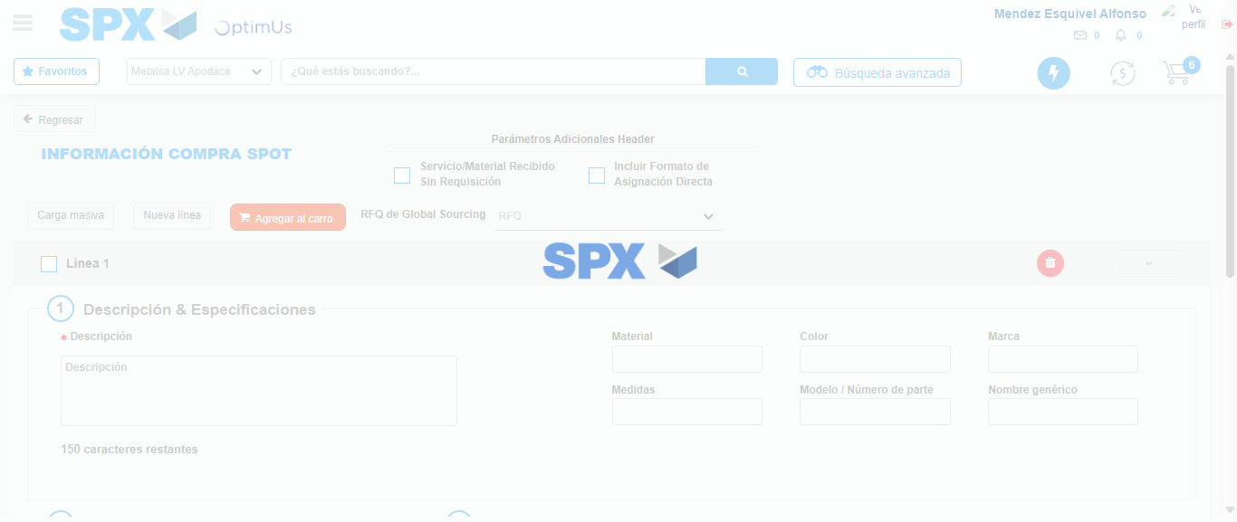Image file-name: QC_Testing-tc002_SPX_Dev5_Crear_Requisicion_Spot_Tipo_Cobro_Project-1783374382204

Step 7 - Return to Main Page SPX : Return to Main Page SPX
Image file-name: QC_Testing-tc002_SPX_Dev5_Crear_Requisicion_Spot_Tipo_Cobro_Project-1783374356890

Image file-name: QC_Testing-tc002_SPX_Dev5_Crear_Requisicion_Spot_Tipo_Cobro_Project-1783374359404

Image file-name: QC_Testing-tc002_SPX_Dev5_Crear_Requisicion_Spot_Tipo_Cobro_Project-1783374365710

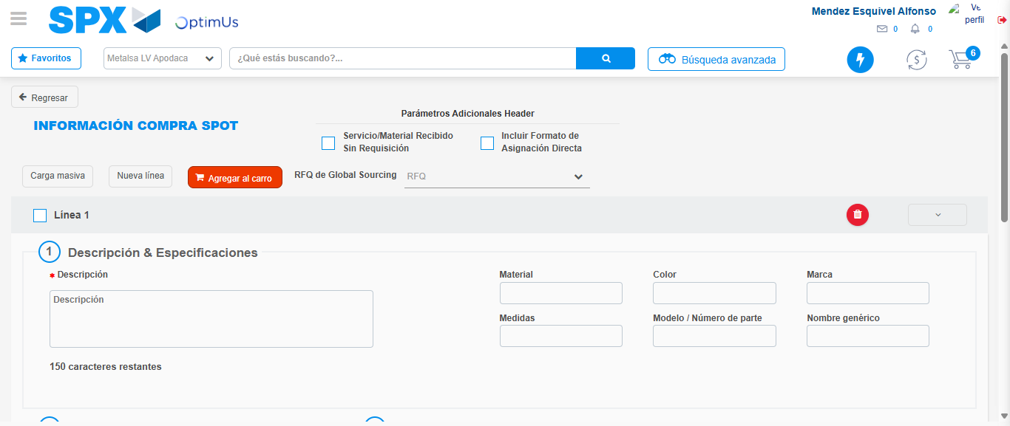Image file-name: QC_Testing-tc002_SPX_Dev5_Crear_Requisicion_Spot_Tipo_Cobro_Project-1783374384443

Image file-name: QC_Testing-tc002_SPX_Dev5_Crear_Requisicion_Spot_Tipo_Cobro_Project-1783374384591

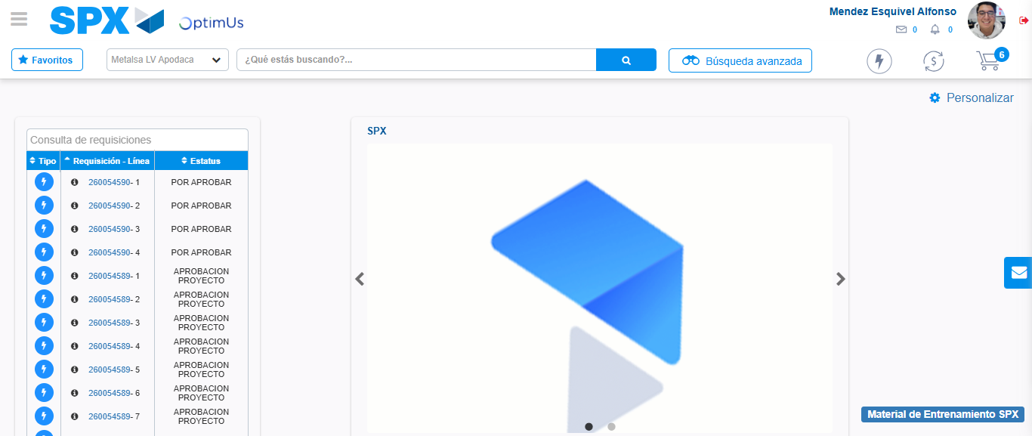Image file-name: QC_Testing-tc002_SPX_Dev5_Crear_Requisicion_Spot_Tipo_Cobro_Project-1783374405634

Step 8 - Log Out : Log Out SPX
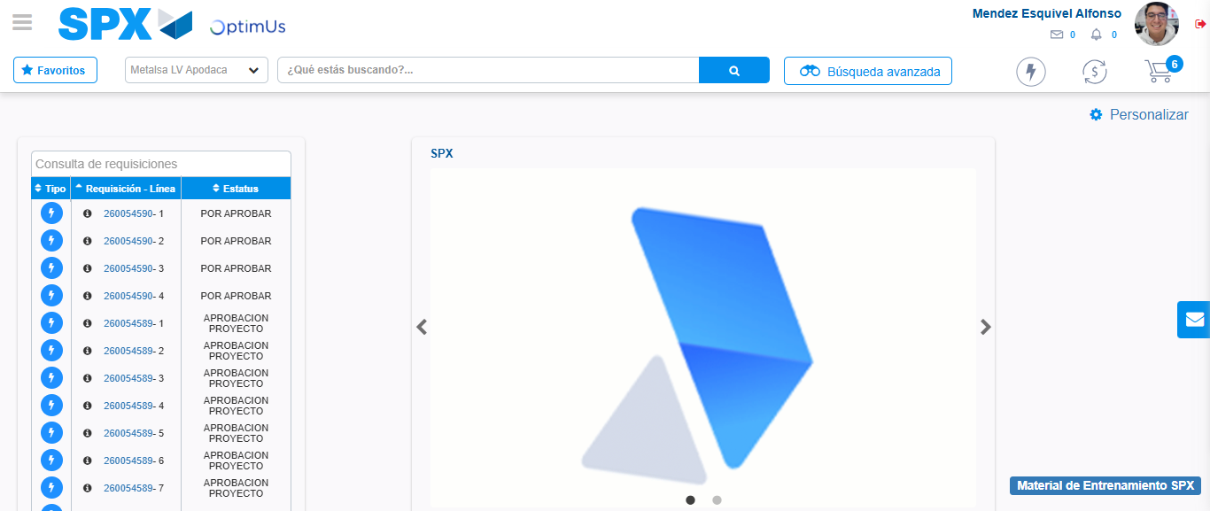Image file-name: QC_Testing-tc002_SPX_Dev5_Crear_Requisicion_Spot_Tipo_Cobro_Project-1783374405849

